Emily Hayden

31 January 2017

CTEC 3350-001

SITEMAP & WIREFRAME

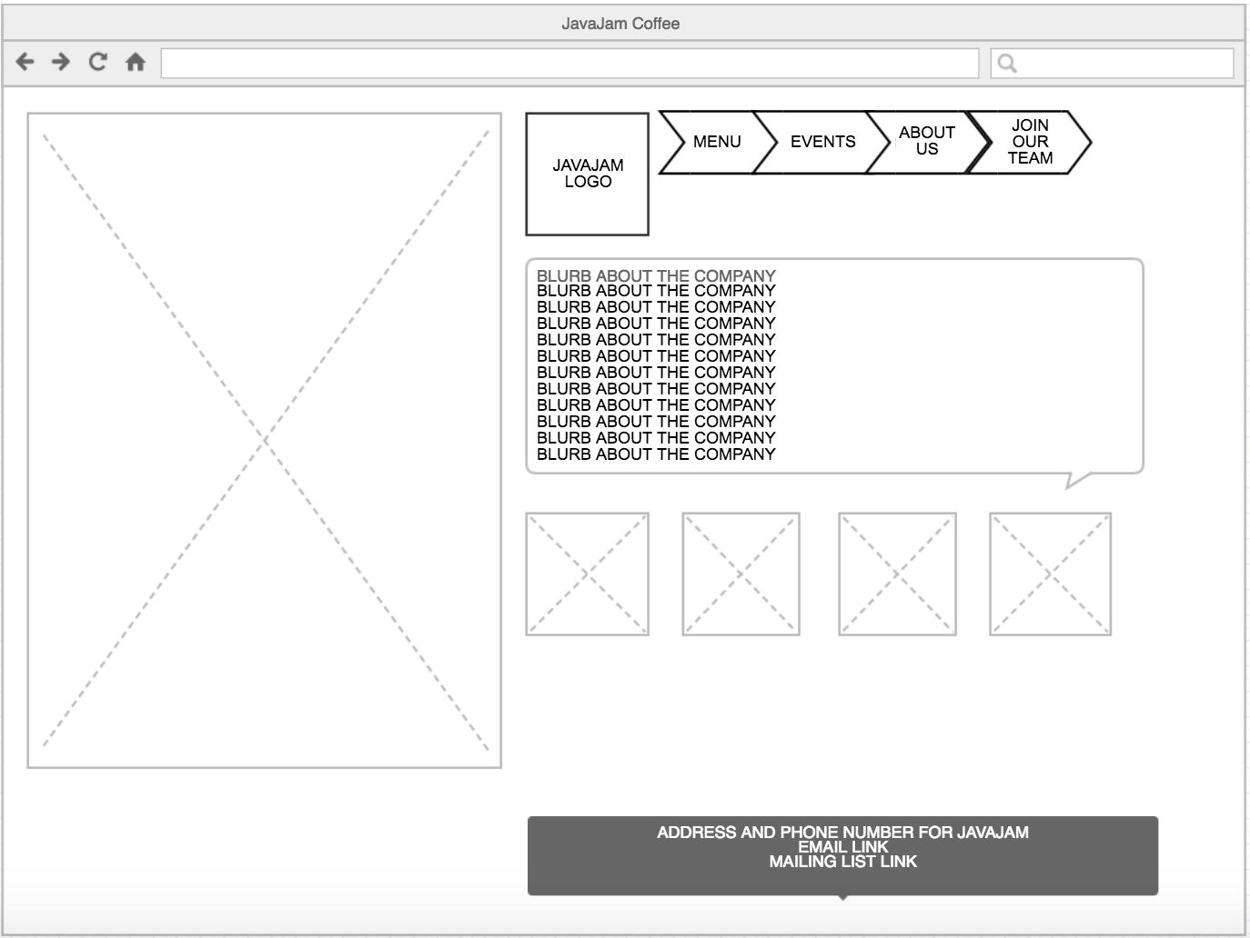

HOME

CALENDER

LIVE MUSIC

POETRY NIGHTS

PASTRIES & SNACKS

COFFEE & TEAS

JOIN OUR TEAM

ABOUT US

EVENTS

MENU